Practical 3: Recursive Function

-Shrisai Halankar

**Aim : To implement recursive function**

**Recursive Function in RStudio:**

**Source code:**

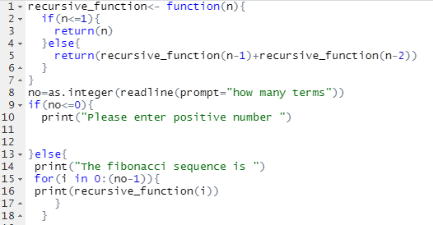

**Output:**

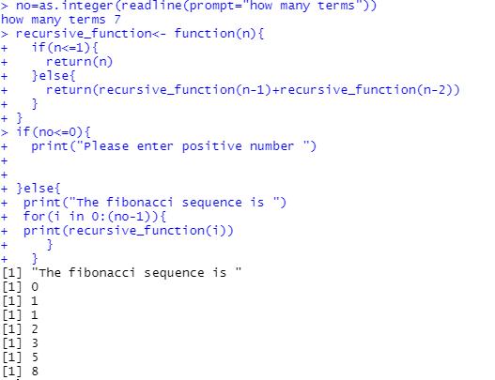

**Recursive function in Python:**

**Source code:**

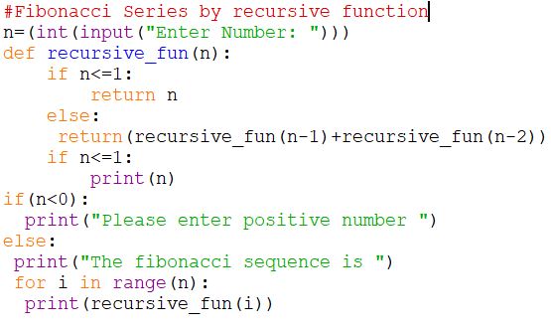

**Output:**

